Bangladesh Medical Association (BMA)
List of Life Member-147
59. BMA Satkhira Branch

Sl No | Voter No | Voter Details
1 | Voter No  LM-5900001  No Image | DR. HAZRAT ALI AHAMED  F/Name: Late Shaharuddin Ahmed  M/Name:  BM & DC Reg. No:  NID:  Cell:  Address: Khanika Chowrangi more, Palashpole, Satkhira  Blood Group:
2 | Voter No  LM-5900002  No Image | DR. YEASMIN JAHAN  F/Name: Late Abdul Gaffer  M/Name:  BM & DC Reg. No:  NID:  Cell:  Address: Consultant Gynae,Sadar Hospital, Satkhira  Blood Group:
3 | Voter No  LM-5900003  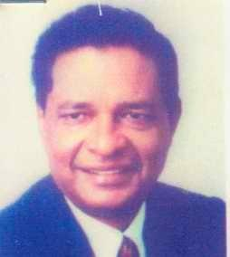 | DR. AFTABUZZAMAN  F/Name: Late Al Haj Dr. Mahjabuddin  M/Name:  BM & DC Reg. No:  NID:  Cell:  Address: Abul Kashem Road, Palashpool, Satkhira  Blood Group:
4 | Voter No  LM-5900004  No Image | DR. MD. MOSHARRAF HOSSAIN  F/Name: Late Belayet Hossain  M/Name:  BM & DC Reg. No:  NID:  Cell:  Address: Asstt. Director (C.C)Family Planning, Satkhira  Blood Group:
5 | Voter No  LM-5900005  No Image | DR. MD. IBRAHIM KHALIL  F/Name:  M/Name:  BM & DC Reg. No:  NID:  Cell:  Address: TRANSFERED to BMA Khulna Branch  Blood Group:  TRANSFERED to BMA Dhaka City  LM-1405543
6 | Voter No  LM-5900006  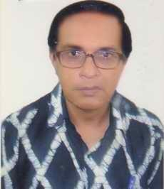 | DR. SHARIF ZAHANGIR ATIQUE  F/Name: Sharif Atiar Rahman  M/Name:  BM & DC Reg. No:  NID:  Cell:  Address: Sadar Hospital, Satkhira  Blood Group:
7 | Voter No  LM-5900007  No Image | DR. MD. ABDUR RAHIM  F/Name: Md. Seamuddin Moral  M/Name:  BM & DC Reg. No:  NID:  Cell:  Address: Medical Officer, Labsha Union and Health F.W Centre, Satkhira  Blood Group:
8 | Voter No  LM-5900008  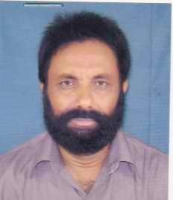 | DR. S.M ABU MUSA  F/Name: Md. Ishaque Ali Sarder  M/Name:  BM & DC Reg. No:  NID:  Cell:  Address: Thana Health Centre, Shamnagar, Satkhira  Blood Group:
9 | Voter No  LM-5900009  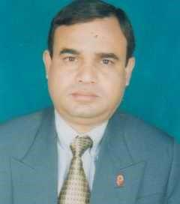 | DR. MD. ABUL BASHAR  F/Name: Md. Rabiul Haque  M/Name:  BM & DC Reg. No:  NID:  Cell:  Address: Medical Officer, Thana Health Complex, Kaligonj, Satkhira  Blood Group:
10 | Voter No  LM-5900010  No Image | DR. MD. TABIBUL ISLAM  F/Name:  M/Name:  BM & DC Reg. No:  NID:  Cell:  Address: TRANSFERED to BMA Khulna Branch  Blood Group:  TRANSFERED to BMA Dhaka City  LM-1405543
11 | Voter No  LM-5900011  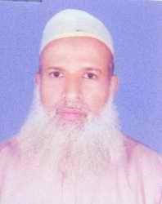 | DR. MD. BARKAT ALI  F/Name: Late Md. Mahtab Ali Moral  M/Name:  BM & DC Reg. No:  NID:  Cell:  Address: High School Road, Patkelghata Bazar, Patkelghata, Tala, Satkhira.  Blood Group:
12 | Voter No  LM-5900012  No Image | DR. MD. ABU DAWOOD  F/Name: Late Sahar Ali  M/Name:  BM & DC Reg. No:  NID:  Cell:  Address: RMO, Sadar Hospital, Satkhira  Blood Group:
13 | Voter No  LM-5900013  No Image | DR. SAKINA KHANAM  F/Name: Late Noor Ali Mia  M/Name:  BM & DC Reg. No:  NID:  Cell:  Address: Sadar Hospital,Satkhira, (Dental Surgeon Not Voter)  Blood Group:
14 | Voter No  LM-5900014  No Image | DR. A.H.M MONIRUZZAMAN  F/Name: Late Md. Darvesh Ali  M/Name:  BM & DC Reg. No:  NID:  Cell:  Address: Sadar Hospital, Satkhira.  Blood Group:
15 | Voter No  LM-5900015  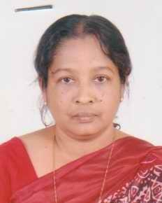 | DR. MST. ANWARA NAZNEEN  F/Name: Md. Seamat Ali Biswas  M/Name:  BM & DC Reg. No:  NID:  Cell:  Address: Sadar Hospital, Satkhira  Blood Group:
16 | Voter No  LM-5900016  No Image | DR. AHSANULLAH AL BAKI  F/Name: Md. Azizur Rahman  M/Name:  BM & DC Reg. No:  NID:  Cell:  Address: Sadar Hospital, Satkhira  Blood Group:
17 | Voter No  LM-5900017  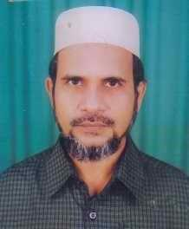 | DR. A.K.M AMINUR RAHMAN  F/Name: Late Md. Atiar Rahman  M/Name:  BM & DC Reg. No:  NID:  Cell:  Address: Satkhira Eye Clinic, Polashpole, Satkhira  Blood Group:
18 | Voter No  LM-5900018 | DR. A.S.M MARUF HASAN  F/Name: Late Shamsul Alam  M/Name:  BM & DC Reg. No:  NID:  Cell:  Address: Civil Surgeon Office, Satkhira.  Blood Group:
19 | Voter No  LM-5900019  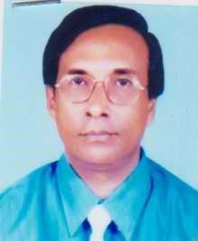 | DR. PRASANTA KUMAR KUNDU  F/Name: Late Abinash Chandra Kundu  M/Name:  BM & DC Reg. No:  NID:  Cell:  Address: Thana Health Complex, Assasuni, Satkhira  Blood Group:
20 | Voter No  LM-5900020  No Image | DR. MD. ABU YUSUF MIAH  F/Name:  M/Name:  BM & DC Reg. No:  NID:  Cell:  Address: TRANSFERED to BMA Dhaka City LM-1402359  Blood Group:  TRANSFERED to BMA Dhaka City  LM-1405543
21 | Voter No  LM-5900021  No Image | DR. MIR MD. ISKANDER ALI  F/Name: Mir Md. Noor Ali  M/Name:  BM & DC Reg. No:  NID:  Cell:  Address: TH&FPO, Satkhira Sadar, Satkhira.  Blood Group:
22 | Voter No  LM-5900022  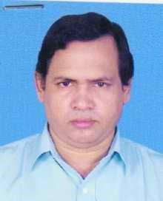 | DR. SHANTI MOHAN BHADRA  F/Name: Late Amulya Behari Bhadra  M/Name:  BM & DC Reg. No:  NID:  Cell:  Address: Resident Medical Officer THC Kalaroa, Satkhira  Blood Group:
23 | Voter No  LM-5900023  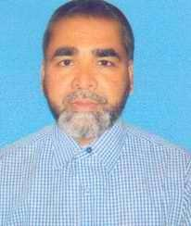 | DR. MD. ABDUR RAHMAN  F/Name: Md. Jobed Ali Sarder  M/Name:  BM & DC Reg. No:  NID:  Cell:  Address: Medical Officer, Kalaroa THC, Satkhira  Blood Group:
24 | Voter No  LM-5900024  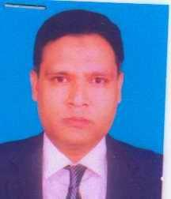 | DR. MD. HABIBULLAH BAHAR  F/Name: Md. Mobarok Ali Tarafder  M/Name:  BM & DC Reg. No:  NID:  Cell:  Address: Royal Dental Surgery, Associate Member, Palashpole, Satkhira., (Dental Surgeon Not Voter)  Blood Group:
25 | Voter No  LM-5900025  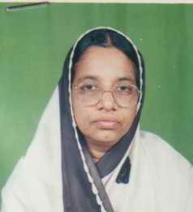 | DR. MALIKA PARVIN  F/Name: Md. Abdur Rahman  M/Name:  BM & DC Reg. No:  NID:  Cell:  Address: Prodip Nibas Villa, Katia, Satkhira.  Blood Group:
26 | Voter No  LM-5900026  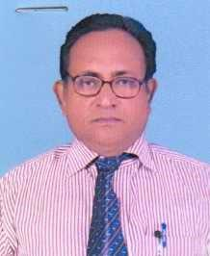 | DR. MD. EBADULLAH  F/Name: Abdul Motaleb Sarder  M/Name:  BM & DC Reg. No:  NID:  Cell:  Address: Thana Health Centre, Debhata, Satkhira  Blood Group:
27 | Voter No  LM-5900027  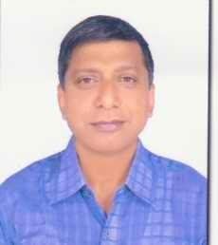 | DR. ARUN KUMAR BANERJEE  F/Name: Anil Kumar Banerjee  M/Name:  BM & DC Reg. No:  NID:  Cell:  Address: Medical Officer, Sadar, Satkhira  Blood Group:
28 | Voter No  LM-5900028  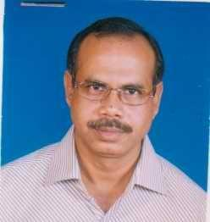 | DR. G.M. MUZIBUR RAHMAN  F/Name: G.m Abdur Razzak  M/Name:  BM & DC Reg. No:  NID:  Cell:  Address: Nahar Pathological Lab. Polashpole, Satkhira  Blood Group:
29 | Voter No  LM-5900029  No Image | DR. ASIT KUMER SWARNOKER  F/Name: Dhirendra Nath Swarnoker  M/Name:  BM & DC Reg. No:  NID:  Cell:  Address: Palashpole, Satkhira  Blood Group:
30 | Voter No  LM-5900030  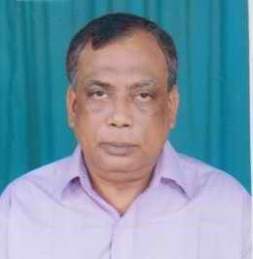 | DR. MD. HABIBUR RAHMAN  F/Name: Late Atiar Rahman  M/Name:  BM & DC Reg. No:  NID:  Cell:  Address: Radiologist,Sadar Hospital, Satkhira  Blood Group:
31 | Voter No  LM-5900031  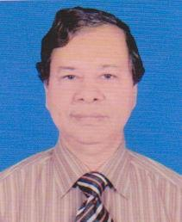 | DR. MD. REZWANUL HAQUE  F/Name: Md. Abdus Samad Molla  M/Name:  BM & DC Reg. No:  NID:  Cell:  Address: Upazila Health and Family Planning Officer,Sadar, Satkhira  Blood Group:
32 | Voter No  LM-5900032  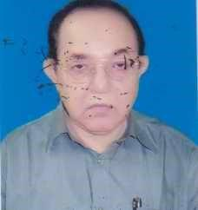 | DR. ABDUL JALIL  F/Name: Late Md. Jinatullah  M/Name:  BM & DC Reg. No:  NID:  Cell:  Address: Vill. + P.O.- Nakipur, Satkhira  Blood Group:
33 | Voter No  LM-5900033  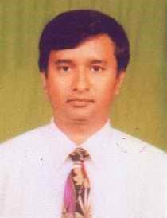 | DR. MUHAMMAD MAMUNUR RASHID  F/Name: F/name: Al Haj Muhammad Abdur Rashid  M/Name:  BM & DC Reg. No:  NID:  Cell:  Address: Amtola Katia, Satkhira  Blood Group:
34 | Voter No  LM-5900034  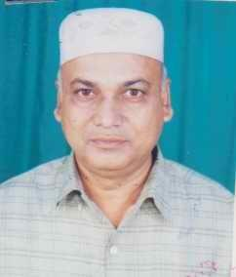 | DR. SYED MOBAROK ALI  F/Name: Late Syed Imam Ali  M/Name:  BM & DC Reg. No:  NID:  Cell:  Address: Civil Surgeon Office, Satkhira  Blood Group:
35 | Voter No  LM-5900035  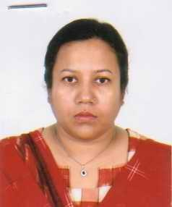 | DR. SALMA AKHTER  F/Name: Al Haj Shafi Uddin  M/Name:  BM & DC Reg. No:  NID:  Cell:  Address: Katia, Satkhira  Blood Group:
36 | Voter No  LM-5900036  No Image | DR. SHYMAPADA PAUL  F/Name: Late Haridas Paul  M/Name:  BM & DC Reg. No:  NID:  Cell:  Address: Polashpole, Satkhira.  Blood Group:
37 | Voter No  LM-5900037  No Image | DR. PRATAP KUMAR KASHYAPI  F/Name: Amar Nath Kashyapi  M/Name:  BM & DC Reg. No:  NID:  Cell:  Address: Per-Kumira USC, Tala Health Complex, Tala, Satkhira.  Blood Group:
38 | Voter No  LM-5900038  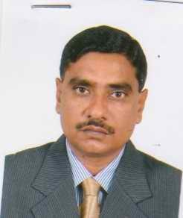 | DR. MOHAMMAD ABUL FAZAL  F/Name: Al Haj Golam Akbar  M/Name:  BM & DC Reg. No:  NID:  Cell:  Address: Sadar Hospital, Satkhira  Blood Group:
39 | Voter No  LM-5900039  No Image | DR. BIPIN BEHARI SARKER  F/Name: Late Fulchand Sarker  M/Name:  BM & DC Reg. No:  NID:  Cell:  Address: Assistant Director, Medical Sub-Dept. Khulna  Blood Group:
40 | Voter No  LM-5900040  No Image | DR. RASHID REZA KHAN  F/Name: Late A. Walied Khan  M/Name:  BM & DC Reg. No:  NID:  Cell:  Address: Vill. Kalia, Post. Satkhira, Satkhira  Blood Group:
41 | Voter No  LM-5900041  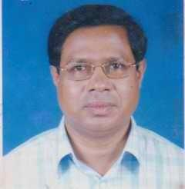 | DR. MUYEEN UDDIN MD. A HANNAN  F/Name: A.B. M A. Raheem  M/Name:  BM & DC Reg. No:  NID:  Cell:  Address: Shyam Nagor, Thana Health Complex, Satkhira  Blood Group:
42 | Voter No  LM-5900042  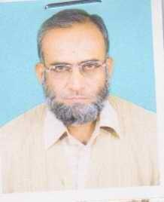 | DR. MD. HABIBULLAH  F/Name: Abdul Hannan  M/Name:  BM & DC Reg. No:  NID:  Cell:  Address: Kaligonj Health Complex, Satkhira  Blood Group:
43 | Voter No  LM-5900043  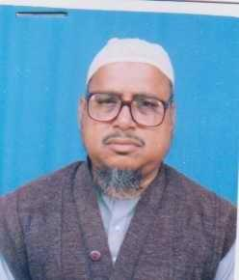 | DR. S. M. MOKHLESUR RAHMAN  F/Name: Al Haj Noor Ahmad Sarder  M/Name:  BM & DC Reg. No:  NID:  Cell:  Address: Polashpole, Jessore Road, Satkhira  Blood Group:
44 | Voter No  LM-5900044  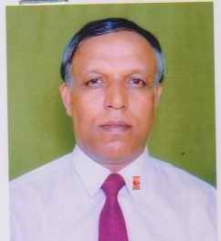 | DR. SUSHANTO KUMAR GHOSH  F/Name: Late Kalipada Ghosh  M/Name:  BM & DC Reg. No:  NID:  Cell:  Address: Jessore Road, Polashpole, Satkhira, Satkhira.  Blood Group:
45 | Voter No  LM-5900045  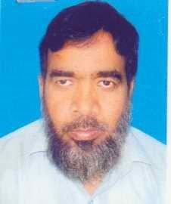 | DR. MD. ZIAD ALI  F/Name: Md. Abdul Jabbar Mollah  M/Name:  BM & DC Reg. No:  NID:  Cell:  Address: Thana Health Complex, Shyamnagor, Satkhira  Blood Group:
46 | Voter No  LM-5900046  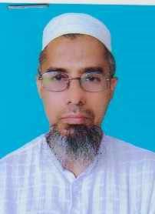 | DR. KHAN HABIBUR RAHMAN  F/Name: Late Bakhtiar Uddin Khan  M/Name:  BM & DC Reg. No:  NID:  Cell:  Address: R.M.O.Thana Health Complex, Shyamnagor, Satkhira  Blood Group:
47 | Voter No  LM-5900047  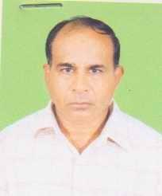 | DR. PROSANTA KUMAR BISWAS  F/Name: Late Karnadhar Biswas  M/Name:  BM & DC Reg. No:  NID:  Cell:  Address: Thana Health Complex,Kalaroa,Satkhira  Blood Group:
48 | Voter No  LM-5900048  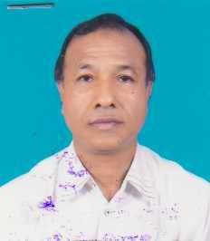 | DR. A..K.M AZIZUR RAHMAN  F/Name: Mecher Uddin Ahmed  M/Name:  BM & DC Reg. No:  NID:  Cell:  Address: Satkhira Children Hospital, Satkhira  Blood Group:
49 | Voter No  LM-5900049  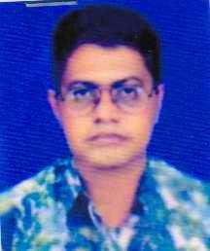 | DR. MADHU SUDAN MONDAL  F/Name: Durgapada Mondal  M/Name:  BM & DC Reg. No:  NID:  Cell:  Address: Patkelghata, Tala, Satkhira  Blood Group:
50 | Voter No  LM-5900050 | DR. MUHAMMAD ASHRAFUL KABIR  F/Name: Muhammad Bani Amine Sarder  M/Name:  BM & DC Reg. No:  NID:  Cell:  Address: Vill. Katia Lasker Para, P.O. Satkhira, Satkhira  Blood Group:
51 | Voter No  LM-5900051 | DR. GAZI KHAN MD. SHAHIDUZZAM  F/Name: Md. Abdur Razzaque  M/Name:  BM & DC Reg. No:  NID:  Cell:  Address: Polashpole, Satkhira  Blood Group:
52 | Voter No  LM-5900052  No Image | DR. M. MAHFUZUL ISLAM KAISAR  F/Name: M. Abul Khair  M/Name:  BM & DC Reg. No:  NID:  Cell:  Address: Civil Surgeon Office, Jessore.  Blood Group:
53 | Voter No  LM-5900053  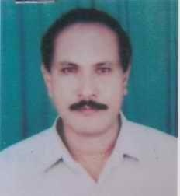 | DR. SUKANTA KUMAR MAZUMDER  F/Name: Late Mr. Sudhir Kumar Mazumder  M/Name:  BM & DC Reg. No:  NID:  Cell:  Address: Health And Familly Planning Office, Sadar, Satkhira.  Blood Group:
54 | Voter No  LM-5900054  No Image | DR. G.M. MAZIDUL ISLAM  F/Name: Late Abdul Quader Gazi  M/Name:  BM & DC Reg. No:  NID:  Cell:  Address: Consultant Ortho, Surgery Sadar Hospital, Satkhira.  Blood Group:
55 | Voter No  LM-5900055  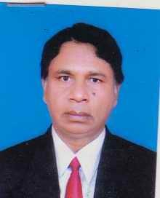 | DR. A.K.M. NURUL ISLAM  F/Name: Late Golam Rahman  M/Name:  BM & DC Reg. No:  NID:  Cell:  Address: Farzana Clinic, Satkhira.  Blood Group:
56 | Voter No  LM-5900056  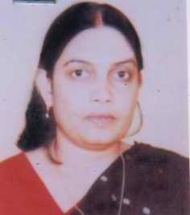 | DR. LIPIKA BISWAS  F/Name: Mr. Haripada Biswas  M/Name:  BM & DC Reg. No:  NID:  Cell:  Address: Maternal & Child Welfare Centre, Satkhira  Blood Group:
57 | Voter No  LM-5900057  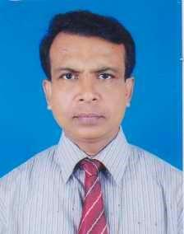 | DR. RANAJIT KUMAR ROY  F/Name: Late Ambica Charan Roy  M/Name:  BM & DC Reg. No:  NID:  Cell:  Address: Medical Officer, MCH-FP, Shyam Nagor, Satkhira  Blood Group:
58 | Voter No  LM-5900058  No Image | DR. MD. FEROZUR RAHMAN  F/Name: Md. Fazlur Rahman  M/Name:  BM & DC Reg. No:  NID:  Cell:  Address: Munshi Para, Satkhira  Blood Group:
59 | Voter No  LM-5900059  No Image | DR. RAWSON ARA  F/Name: Md. Abdul Kader Sikder  M/Name:  BM & DC Reg. No:  NID:  Cell:  Address: Transfered to Chittagong Branch  Blood Group:
60 | Voter No  LM-5900060  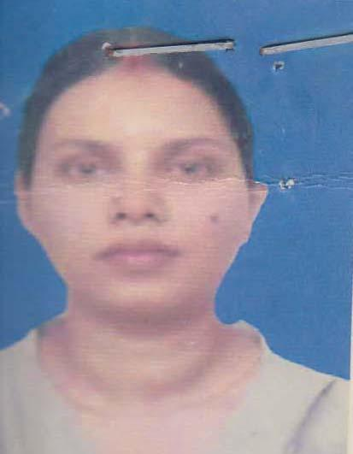 | DR. SHUTAPA CHATTERJEE  F/Name: Ashis Kumar Chatterjee  M/Name: Mita Chatterjee  BM & DC Reg. No: 36362  NID: 2727704417222  Cell: 01712919262  Address: 280/2, Bangla Sharak Rayer Bazar, Dhaka  Blood Group: n_a
61 | Voter No  LM-5900061 | DR. NARAYAN PROSHAD SANYAL  F/Name: Shambhu Nath Sanyal  M/Name: Durga Rani  BM & DC Reg. No: 26034  NID:  Cell:  Address: Vill. & Post Islamkoti Ps- Tala Satkhira  Blood Group:
62 | Voter No  LM-5900062 | DR. A.S.M ZAHIRUL HASAN  F/Name: Alhaj Md. Abdul Gabber  M/Name: Mrs. Gamila Khatun  BM & DC Reg. No: 12453  NID: 8719087961731  Cell: 01711840533  Address: UH&FPO, UHC, Tala, Satkhira  Blood Group: A+
63 | Voter No  LM-5900063  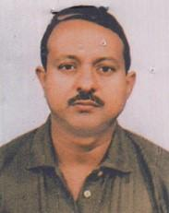 | DR. DEBDULAL SARKAR  F/Name: Late Surajam Sarkar  M/Name: Protiva Sarkar  BM & DC Reg. No: 25655  NID:  Cell:  Address: Satata Clinic Poslesh Pola Satkhira  Blood Group:
64 | Voter No  LM-5900064  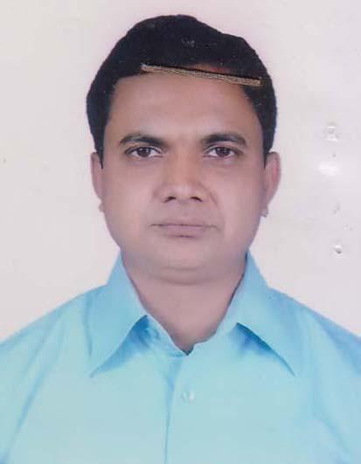 | DR. MD. MONOAR HOSSAIN  F/Name: Md Golam Mostafa  M/Name: Mrs Khaleda Begum  BM & DC Reg. No: 31381  NID: 2696406011523  Cell: 01712335767  Address: UHC, Tala, Satkhira  Blood Group: B+
65 | Voter No  LM-5900065  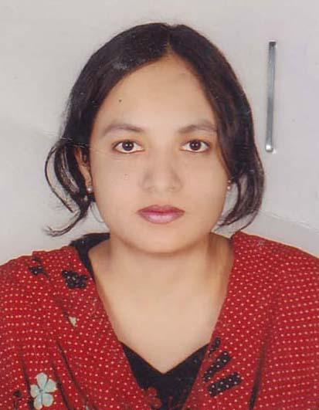 | MD.SABERA SULTANA  F/Name: Sk. A. Sabur  M/Name: Zakera Khatun  BM & DC Reg. No: 44081  NID: 8728204121743  Cell: 01712256959  Address: Sultanpur, Satkhira  Blood Group: B+
66 | Voter No  LM-5900066 | DR. MD. SHAMSUR RAHMAN  F/Name: Md. Keramat Ali Biswas  M/Name: Mrs. Anwara Begum  BM & DC Reg. No: 37992  NID: 2696352227439  Cell: 01711143672  Address: Vill: Chupria, PO: Balladanga, PS & Dist: Satkhira  Blood Group: B+
67 | Voter No  LM-5900067  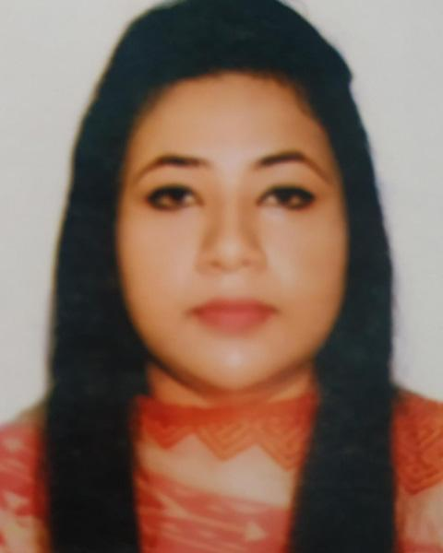 | DR. NESHWA RAHMAN NOVA  F/Name: Dr. A K M Azizur Rahman  M/Name: Mrs. Farukhi Naznin  BM & DC Reg. No: 69160  NID: 8243972505  Cell: 01736212123  Address: "House # Neshwa", P.O. Rasulpur, Thana & Dist. Satkhira.  Blood Group: AB+
68 | Voter No  LM-5900068 | DR. UTPAL KUMAR DEBNATH  F/Name: Dulal Krishna Debnath  M/Name: Late Kamola Rani Debnath  BM & DC Reg. No: 13326  NID: 0113484143523  Cell: 01711188896  Address: Civil Surgeon Satkhira  Blood Group: O+
69 | Voter No  LM-5900069 | DR. MD. MAKSUDUL ANAM SIDDIQUI  F/Name: Late Dr. Md. Quamrul Anam Siddiqui  M/Name: Mrs. Morzina Siddiqui  BM & DC Reg. No: 17548  NID: 8728202105654  Cell: 01553336431  Address: New College Road, Kachari Para, Satkhira  Blood Group: O+
70 | Voter No  LM-5900070  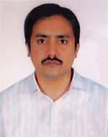 | DR. QUAZI ARIF AHMED  F/Name: Quazi Zafar Ahmed  M/Name: Farida Khatun  BM & DC Reg. No: 28701  NID: 2694811042842  Cell: 01819208425  Address: Nahar Diagnostic Centre Polashpole, Satkhira  Blood Group: n_a
71 | Voter No  LM-5900071  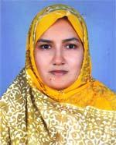 | DR. FARHANA HOSSAIN  F/Name: Late Md. Zakir Hossain  M/Name: Late Selina Hossain  BM & DC Reg. No: 32144  NID: 2694811042843  Cell: 01770345266  Address: Nahar Diagnostic Centre Polashpole, Satkhira  Blood Group: B+
72 | Voter No  LM-5900072 | DR. MD. ASADUZZAMAN  F/Name: Md. Anwar Hossain  M/Name: Saleha Khatun  BM & DC Reg. No: 27364  NID: 8714313915560  Cell: 01729687445  Address: Vai Vai Sanitary, Chourongir Mor, Polashpole, Satkhira  Blood Group: A+
73 | Voter No  LM-5900073  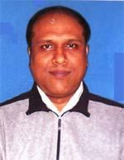 | DR. G. M. FARUQUZZAMAN  F/Name: Late G. M. Fazlul Karim  M/Name: Mst.fazilatunnesa  BM & DC Reg. No: 30086  NID: 8714713204177  Cell: 01711467003  Address: Jr. Consultant (Ent) Sadar Hospital, Satkhira  Blood Group: O+
74 | Voter No  LM-5900074  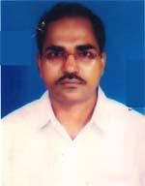 | DR. MD. ENAMUL HAFIZ  F/Name: Dr. Md. Abdur Rahman  M/Name: Mrs. Momtaz Begum  BM & DC Reg. No: 36538  NID: 8712531527510  Cell: 01711208503  Address: Rasulpur. Satkhira Sadar, Satkhira  Blood Group: AB+
75 | Voter No  LM-5900075  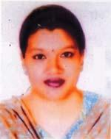 | DR. NAZMUN NAHAR  F/Name: Md. Azizur Rahman  M/Name: Atfa Begum  BM & DC Reg. No: 55521  NID: 2696653255623  Cell: 01917864095  Address: Rosulpur, Satkhira Sadar, Satkhira  Blood Group: O+
76 | Voter No  LM-5900076 | DR. MD. HASANUZZAMAN  F/Name: Md. Kafiluddin Ahmed  M/Name: Mrs. Sabironnesa  BM & DC Reg. No: 35446  NID: 19788718254262709  Cell: 01732936232  Address: Junior Consultan (surg) , Sadar Hospital, Satkhira  Blood Group: O-
77 | Voter No  LM-5900077  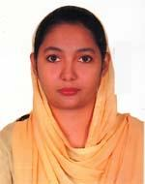 | DR. MOKERROMA FERDOUS  F/Name: Md. Jamshed Ali  M/Name: Shaheeda Khatun  BM & DC Reg. No: 46189  NID: 4124706084281  Cell: 01711902600  Address: Shastitalapara, Satkhira.  Blood Group: B+
78 | Voter No  LM-5900078 | DR. MST. RAHIMA KHATUN  F/Name: Md. Mobarak Ali  M/Name: Mst. Khadiza Begum  BM & DC Reg. No: 24878  NID: 2695044876074  Cell: 01819946599  Address: Sadar Hopital Satkhira Jr. Consultant (O+G)  Blood Group: A+
79 | Voter No  LM-5900079  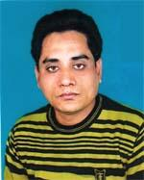 | DR. MD. SHARIFUL ISLAM  F/Name: Md. Abdur Rahim Moral  M/Name: Mrs. Fatema Rahim  BM & DC Reg. No: 35475  NID: 8728208246836  Cell: 01715999089  Address: Junior Consultant (Surgery) Sadar Hospital, Satkhira  Blood Group: AB+
80 | Voter No  LM-5900080 | DR. PROBIR KUMAR DAS  F/Name: Late Ananta Kumar Das  M/Name: Gita Rani Das  BM & DC Reg. No: 34521  NID: 8198503435376  Cell: 01712555992  Address:  Blood Group: O+
81 | Voter No  LM-5900081  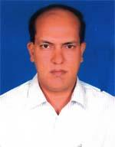 | DR. PROBIR KUMER MUKHERJEE  F/Name: Late Satya Ranjan Mukherjee  M/Name: Geeta Mukherjee  BM & DC Reg. No: 23679  NID: 8728208155549  Cell: 01817401830  Address: Polashpole, Satkhira  Blood Group: B+
82 | Voter No  LM-5900082  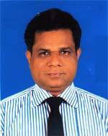 | DR. HARASHIT CHAKRABARTY  F/Name: Late Hari-narayan Chakrabarty  M/Name: Kajal Rani Chakrabarty  BM & DC Reg. No: 21939  NID: 19678728202100144  Cell: 01711310428  Address: South Katia , Sarkar Para, Thana-Satkhira, Dist-Satkhira  Blood Group: A+
83 | Voter No  LM-5900083 | DR. MEHNAZ NAZRIN  F/Name: Dr. Abdur Rahman  M/Name: Momotaz Begum  BM & DC Reg. No: 49129  NID: 19821594116382698  Cell: 01712555836  Address: 457, Govt. college road, Katta, Satkhira  Blood Group: B+
84 | Voter No  LM-5900084 | DR. SHEIKH ABU SAYEED  F/Name: Sheikh Abdul Wadud  M/Name: Mrs. Sherina Wadud  BM & DC Reg. No: 29242  NID: 1974069511118917  Cell: 01911409168  Address: 457 , Govt. College Road, Satkhira  Blood Group: A+
85 | Voter No  LM-5900085  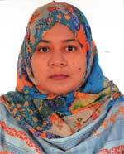 | DR. KANIZ FATEMA  F/Name: Abdus Sattar  M/Name: Wahida Akter  BM & DC Reg. No: 42467  NID: 0695112193868  Cell: 01711704261  Address: 66 Karim Bug, Radhavagar, Palaspoli, Satkhira-9400  Blood Group: O+
86 | Voter No  LM-5900086  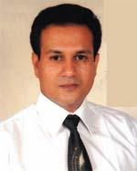 | DR. SHAIKH NAZMUS SAQUEEB  F/Name: S. A. Karim  M/Name: Feeroza Begum  BM & DC Reg. No: 42468  NID: 0695112193867  Cell: 01712528865  Address: Karim Bug, Radhavagar, Pabspoli, Satkhira-9400  Blood Group: O+
87 | Voter No  LM-5900087  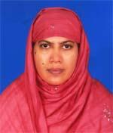 | DR. ROKEYA GULSHAN ARA  F/Name: Late Md. Ruhul Amin  M/Name: Mrs. Rabeya Khatun  BM & DC Reg. No: 28045  NID: 6872887838  Cell: 01725023944  Address: North Polasapol, Satkhira-9400.  Blood Group: A+
88 | Voter No  LM-5900088  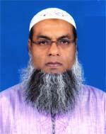 | DR. MD. ABDUR RAZZAQUE  F/Name: Late Md. Ballack Sarder  M/Name: Late Vodi Bibi  BM & DC Reg. No: 19604  NID: 8728208155401  Cell: 01711309360  Address: Polashpole, Satkhira. Dist-Satkhira  Blood Group: AB+
89 | Voter No  LM-5900089 | DR. TANVIR AHMED  F/Name: Md. Hemayet Uddin  M/Name: Alia Begum  BM & DC Reg. No: 39896  NID: 2697557398010  Cell: 01732770350  Address: 68, Khal Sharak, Radha Nagar, Satkhira  Blood Group: B+
90 | Voter No  LM-5900090 | DR. ABHIJIT ROY  F/Name: Late Bisoy Krishna Roy  M/Name: Usha Ray  BM & DC Reg. No: 39980  NID: 8718267364347  Cell: 0171115356  Address: Satkhira.  Blood Group: A+
91 | Voter No  LM-5900091  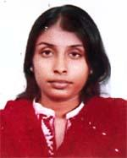 | DR.TANDRA GHOSH  F/Name: Sanjib Kumar Ghosh  M/Name: Sumitra Rani Ghosh  BM & DC Reg. No: 62213  NID: 19892696066782394  Cell: 01714480075  Address: Vill+Post-Jhaudanga, Thana+Dist-Satkhira  Blood Group: A+
92 | Voter No  LM-5900092  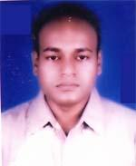 | DR. MD. EHSAN MAHMOOD  F/Name: Late Azizur Rahman  M/Name: Late Mahmuda Rahman  BM & DC Reg. No: 38366  NID: 19778728208000005  Cell: 01715010553  Address: Kamal Nagor, Satkhira  Blood Group: O+
93 | Voter No  LM-5900093  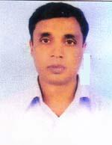 | DR. SUJIT ROY  F/Name: Late Benoy Krishna Roy  M/Name: Usha Roy  BM & DC Reg. No: 40444  NID: 8718267364106  Cell: 01711306788  Address: Vill+Post-Jhaudanga, Thana+Dist-Satkhira  Blood Group: A+
94 | Voter No  LM-5900094 | DR. TANOY KRISHNA PAUL  F/Name: Chitta Ranjan Paul  M/Name: Chapola Bala Paul  BM & DC Reg. No: 21359  NID: 8728209129419  Cell: 01714050570  Address: Chowrangi More, Palashpol, Satkhira  Blood Group: B+
95 | Voter No  LM-5900095  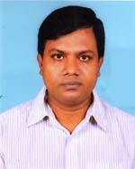 | DR. MD. KABIRUL ISLAM  F/Name: Late Maula Bokhsha  M/Name: Late Zohura Khatun  BM & DC Reg. No: 41453  NID: 8710434600911  Cell: 01717463854  Address: Sabit Nibas, Boubazar, Polashpole, Satkhira  Blood Group: O+
96 | Voter No  LM-5900096  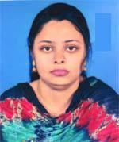 | DR. SHARIFA ZAHAN  F/Name: Md. Alfaz Uddin  M/Name: Hasina Begum  BM & DC Reg. No: 56388  NID: 8718294226706  Cell: 01716261978  Address: Sabit Nibash, Polashpole Bow Bazar, Satkhira  Blood Group: A+
97 | Voter No  LM-5900097  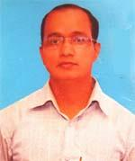 | DR. SANJAY KUMAR RAY  F/Name: Bhabendra Nath Ray  M/Name: Promila Rani Ray  BM & DC Reg. No: 61235  NID: 8198510366853  Cell: 01723306903  Address: Doctor's Quarter UHC, Satkhira.  Blood Group: B+
98 | Voter No  LM-5900098 | DR. MD. SHAMIMUL KABIR  F/Name: Noor Mohammad  M/Name: Shirajun Nahar  BM & DC Reg. No: 44940  NID: 19822697557398601  Cell: 01717997299  Address: Noor Monjil, Vill-Chalitabaria, Post-Varashimla, P.S-Kaligonj, Dist-Satkhira  Blood Group: O+
99 | Voter No  LM-5900099 | DR. MD. NASIR UDDIN GAZI  F/Name: Md. Malo Baksa Gazi  M/Name: Ashura Khatun  BM & DC Reg. No: 42967  NID: 1517017804042  Cell: 01749849533  Address: Eng. Hamid Vila, Khulna Road Moar Po2 Ashpole, Satkhira  Blood Group: B+
100 | Voter No  LM-5900100  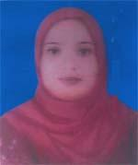 | DR. NASRIN NAHAR  F/Name: Md. Siraj Uddin  M/Name: Fahima Khatun  BM & DC Reg. No: 56125  NID: 8712579530021  Cell: 01762119990  Address: Vill-Kazimahalla, Post+Thana-Debhata, Dist-Satkhira  Blood Group: O+
101 | Voter No  LM-5900101  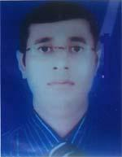 | DR. MD. SHAHRIAR MAMUN  F/Name: Md. Matiur Rahman  M/Name: Noorjahan Begum  BM & DC Reg. No: 52701  NID: 19850695111184878  Cell: 01717611330  Address: Vill-Nathpur, Post-Bujtala, Thana-Kalaroa, Dist-Satkhira  Blood Group: B+
102 | Voter No  LM-5900102 | DR. MD. ARIFUZZAMAN  F/Name: Khondoker Asaduzzaman  M/Name: Shamima Aktar Jahan  BM & DC Reg. No: 60182  NID:  Cell: 01717354587  Address: Room-225, Sadar Hospital Satkhira  Blood Group: B-
103 | Voter No  LM-5900103  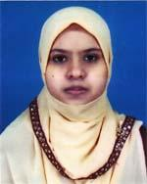 | DR. JAHANARA AKTER  F/Name: S. M. Asrar Hossain  M/Name: Mrs. Mouluda Begum  BM & DC Reg. No: 60177  NID: 8728202101428  Cell: 01723068543  Address: Vill-Munjitpur, Post+P.S-Satkhira, Dist-Satkhira  Blood Group: A+
104 | Voter No  LM-5900104  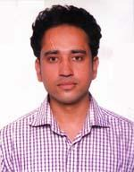 | DR. MD. ARIFUZZAMAN  F/Name: Md. Abdul Matin  M/Name: Tahmina Khatun  BM & DC Reg. No: 63563  NID: 4798516214727  Cell: 01723003683  Address: Vill-Kashempur, Post-Rasulpur, P.S-Satkhira Sadar, Dist-Satkhira  Blood Group: A+
105 | Voter No  LM-5900105  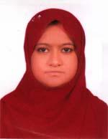 | DR.FATEMA JOHORA  F/Name: Md. Mostafizur Rahman  M/Name: Mostari Begum  BM & DC Reg. No: 62112  NID: 19896125214204229  Cell: 01745570909  Address: Telephone office, Munjeetpur, Satkhira  Blood Group: B+
106 | Voter No  LM-5900106 | DR. MOHOSANA KHANAM  F/Name: Md. Moslem Uddin  M/Name: Afsari Khanam  BM & DC Reg. No: 59565  NID: 2695044887567  Cell: 01746367321  Address: College Road, Munshi Para, Satkhira  Blood Group: AB+
107 | Voter No  LM-5900107  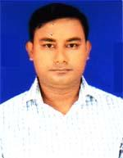 | DR. MD. AZMAL HOSSAIN  F/Name: Md. Tabarok Hossain  M/Name: Rahima Khatun  BM & DC Reg. No: 59478  NID: 19878718216000004  Cell: 01720589576  Address: Vill+Post-Alipur, Thana+Dist-Satkhira  Blood Group: B+
108 | Voter No  LM-5900108 | DR. A.H.M. ASHADUZZAMAN  F/Name: S. M. Abdur Razzaque  M/Name: Lutfunnesa  BM & DC Reg. No: 50763  NID: 8718227343  Cell: 01712083118  Address: Vill-Mochra, Post-Akhrakhola, Thana+Dist-Satkhira  Blood Group: B+
109 | Voter No  LM-5900109 | DR. SK. TAIABUR RAHMAN  F/Name: Sk. Habibur Rahman  M/Name: Tahmina Habiba  BM & DC Reg. No: 50498  NID: 19792691650000019  Cell: 01712516424  Address: Emo, Sadar Hospital, Satkhira  Blood Group: A+
110 | Voter No  LM-5900110 | DR. MD. RAZIB KAWSHER  F/Name: Dr. S. M. Mokhlesur Rahman  M/Name: Late Nazmun Nahar  BM & DC Reg. No: 39861  NID: 8710469576846  Cell: 01912449929  Address: Nazmun Clinic, Polaspole Satkhira  Blood Group: B+
111 | Voter No  LM-5900111  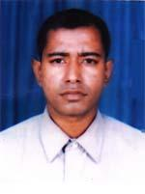 | DR. MD. ASHIF KAWSHER  F/Name: Dr. S.m Moklesur Rahman  M/Name: Late Nazmun Nahar  BM & DC Reg. No: 41542  NID:  Cell: 01767412424  Address: Vill-Polash Pole, Thana+Dist-Satkhira  Blood Group: B+
112 | Voter No  LM-5900112  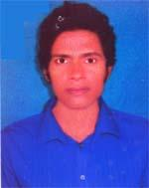 | DR. MD. MAHBUBAR RAHMAN  F/Name: Md. Abul Kashem  M/Name: Aleya Khatun  BM & DC Reg. No: 44113  NID: 8714394962666  Cell: 01716033649  Address: Tulsidanga, Hospital road, kalaroal, Satkhira  Blood Group: B+
113 | Voter No  LM-5900113  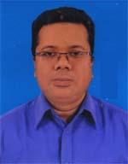 | DR. SUDIPTASHEKHAR DEBNATH  F/Name: Suvash Chandra Debnath  M/Name: Sunanda Debnath  BM & DC Reg. No: 38512  NID: 2698877289327  Cell: 01725127152  Address: Munjitpur, Satkhira  Blood Group: O+
114 | Voter No  LM-5900114 | DR. MD. MAHAMUDUL HASAN  F/Name: Md. Shahidul Islam  M/Name: Mrs. Rebeka Khanom  BM & DC Reg. No: 45932  NID: 8719011441546  Cell: 01712235717  Address: Katya, Satkhira  Blood Group: B+
115 | Voter No  LM-5900115  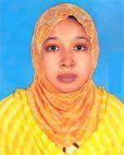 | DR. KANIZ FATEMA  F/Name: A. H. M. Abdul Kadim  M/Name: Late Fatema Sultana  BM & DC Reg. No: 63651  NID: 2617272869214  Cell: 01712235717  Address: Katya, Satkhira  Blood Group: B+
116 | Voter No  LM-5900116  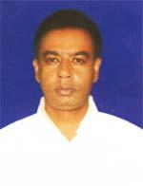 | DR. MD. MEHER ULLAH  F/Name: Late Johor Ali Morol  M/Name: Late Meherunnesa  BM & DC Reg. No: 34435  NID: 8714347996287  Cell: 01712206654  Address: Doctor's Quarter, UHC, Kalaroa,Satkhira  Blood Group: B+
117 | Voter No  LM-5900117  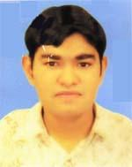 | DR. DK. FAISAL AHMED  F/Name: A.k.m. Mohiuddin  M/Name: Rowshan Ara Begum  BM & DC Reg. No: 49067  NID: 0695111185394  Cell: 01711585158  Address: Vill-Katia, Post+Thana+Dist-Satkhira  Blood Group: A+
118 | Voter No  LM-5900118 | DR. MD. HAFIZ ULLAH  F/Name: Late Mosarraf Hossain  M/Name: Mrs. Rokeya Begum  BM & DC Reg. No: 40701  NID:  Cell: 01917862476  Address: Chowdhurypara, Northkatia, Satkhira  Blood Group: AB+
119 | Voter No  LM-5900119 | DR. IQBAL MAHMUD  F/Name: Kamal Uddin  M/Name: Kamrunnahar  BM & DC Reg. No: 65249  NID: 4798516226980  Cell: 01710240101  Address: Home-22 #, Road No. 2/8 # , Dalal Sarak, Amtala, Katia, Satkhira  Blood Group: B+
120 | Voter No  LM-5900120  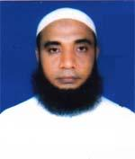 | DR. KHAN GOLAM MOSTAFA  F/Name: Late Khan Mohar Ali  M/Name: Matia Begum  BM & DC Reg. No: 16389  NID: 8728209168192  Cell: 01558812782  Address: Associate Professor of Pediatics, Satkhira Medical College, Satkhira  Blood Group: A+
121 | Voter No  LM-5900121  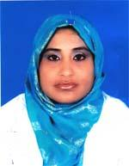 | DR. NASRIN SUTANA  F/Name: Md. Jahurul Islam  M/Name: Mrs. Masuda Khatun  BM & DC Reg. No: 42886  NID: 8728202101500  Cell: 01746305959  Address: Living area: Urban, Post-Satkhira, PC-9400, Dist-Satkhira  Blood Group: O+
122 | Voter No  LM-5900122  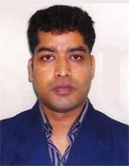 | DR. MD. ABDUL LATIF  F/Name: Md. Mobarak Ali Mollah  M/Name: Mrs. Fazilatun Nesa  BM & DC Reg. No: 40063  NID: 19798712515608506  Cell: 01712722896  Address: Medical officer, Upazilla Health Complex, Kaligonj, Satkhira  Blood Group: AB+
123 | Voter No  LM-5900123 | DR. MOHAMMAD DELUAR HOSSAIN  F/Name: Mohammad Kalu Mia  M/Name: Mst. Noorjahan Begum  BM & DC Reg. No: 37646  NID: 8192227210641  Cell: 01713108031  Address: North Polashpole, Sathkhira Sadar, Satkhira.  Blood Group: AB+
124 | Voter No  LM-5900124  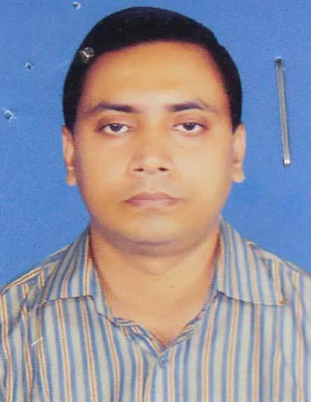 | DR. JAYANTA SARKER  F/Name: Dr. Bipin Behari Sarker  M/Name: Monju Rani Sarker  BM & DC Reg. No: 47929  NID: 8728209126364  Cell: 01711446323  Address: Vill: Polashpole(West Para), P.O, Thana & Dist: Satkhira.  Blood Group: O+
125 | Voter No  LM-5900125  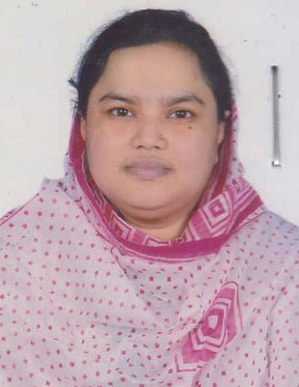 | DR. NAHID SULTANA  F/Name: Md. Abdul Khaleque  M/Name: Shakila Iesmin  BM & DC Reg. No: 79843  NID: 8728203103283  Cell: 01715603940  Address: Puraton Satkhira, Satkhira.  Blood Group: B+
126 | Voter No  LM-5900126  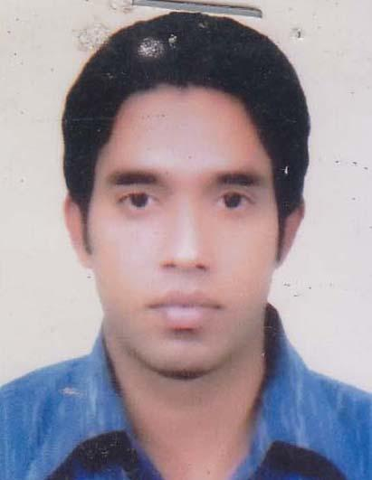 | DR. SAIDUR RAHMAN  F/Name: Sheyer Ali Sarder  M/Name: Sajeda Khatun  BM & DC Reg. No: 84711  NID: 19898524904000046  Cell: 01722555359  Address: Polaspol Satkhira.  Blood Group: O+
127 | Voter No  LM-5900127 | DR. MD. RASIDUZZAMAN  F/Name: Alahaj Abu Daud  M/Name: Alhaj Rizia Khatun  BM & DC Reg. No: 48644  NID: 19848724303000003  Cell: 01715030328  Address: Polashpole, Satkhira.  Blood Group: O+
128 | Voter No  LM-5900128  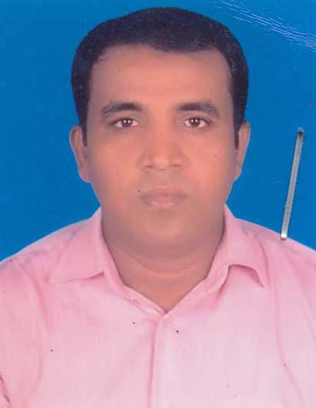 | DR. MD. AMINUL ISLAM  F/Name: Md. Abu Bakar Siddique  M/Name: Asma Khatun  BM & DC Reg. No: 63116  NID: 8714779207712  Cell: 01763161457  Address: Polashpole, Khulna Road, Satkhira.  Blood Group: A+
129 | Voter No  LM-5900129  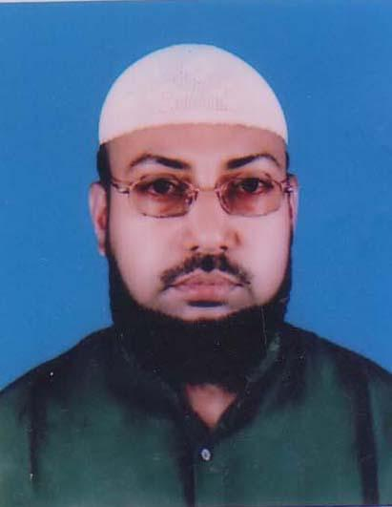 | DR. S.K QUDRAT E KHUDA  F/Name: Sk.m. Abul Hossain  M/Name: Mrs. Shamsun Nahar  BM & DC Reg. No: 24384  NID: 1927016608  Cell: 01911138752  Address: Asst. Director, Satkhira Medical College Hospital.  Blood Group: A+
130 | Voter No  LM-5900130  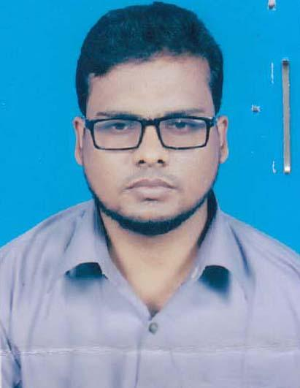 | DR. ABU BAKAR SIDDIQ  F/Name: S.k. Abdul Aziz  M/Name: Begum Rashida Khatun  BM & DC Reg. No: 51318  NID: 19832693622000003  Cell: 01762656184  Address: Vill: Borobila, Post: Patkelghata, Thana; Patkelghata, Dist: Satkhira.  Blood Group: A+
131 | Voter No  LM-5900131  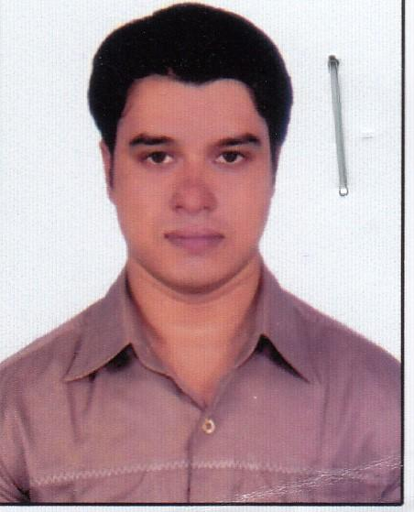 | DR. SAIFULLA AL KAFI  F/Name: Md. Shahidullah  M/Name: Anjumanara  BM & DC Reg. No: A 68883  NID: 2838064125  Cell: 01710974297  Address: Road : 3/1, House:4/1, North Polaspole,: Satkhira.  Blood Group: A+
132 | Voter No  LM-5900132  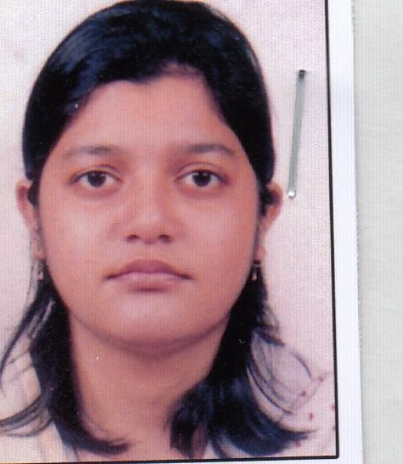 | DR. MAHFUZA AKTER  F/Name: Ramiz Uddin Ahmed  M/Name: Sultana Razia  BM & DC Reg. No: A 68884  NID: 7305696861  Cell: 01741952049  Address: Road : 3/1, House:4/1, North Polaspole,: Satkhira  Blood Group:
133 | Voter No  LM-5900133  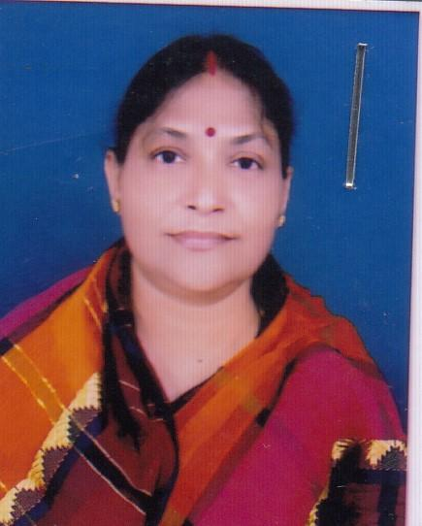 | DR. SULEKHA MUKHOPADHYAY  F/Name: Sudhindra Kumar Mukherjee  M/Name: Uma Rani Mukherjee:  BM & DC Reg. No: A 18872  NID: 8710434846055  Cell: 01715035090  Address: Vill: Beula, Post: paithali, Thana: Assasuni, Dist: Satkhira.  Blood Group: B+
134 | Voter No  LM-5900134  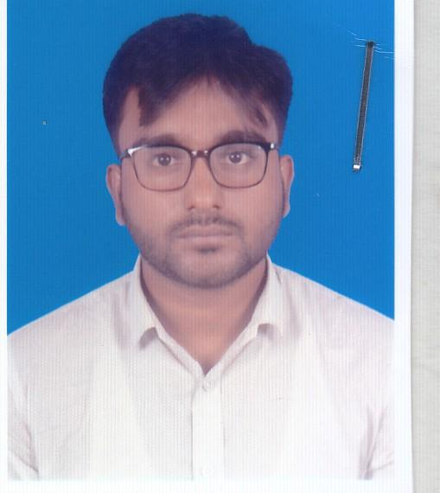 | DR. MUBARAK HOSEN  F/Name: Md. Abul Basar  M/Name: Minara Begum  BM & DC Reg. No: A 95260  NID: 19941317973004755  Cell: 01747464764  Address: 103/1,Khulna Road, Palashpol : Satkhira Sadar, Satkhira.  Blood Group: B+
135 | Voter No  LM-5900135  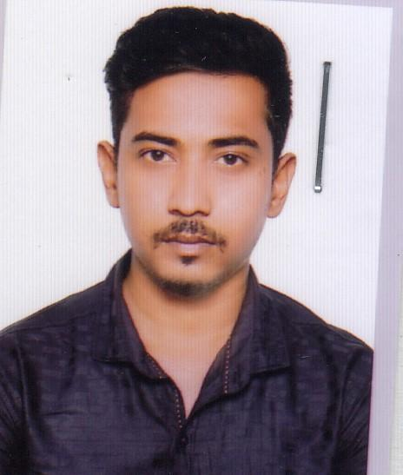 | DR. MD. ABUL BASHAR  F/Name: Md. Enayet Kabir  M/Name: Rehena Parveen  BM & DC Reg. No: A 91576  NID: 1992792580200029  Cell: 01724140181  Address: 103/1, Khulna Road, Palashpol : Satkhira Sadar, Satkhira.  Blood Group: A+
136 | Voter No  LM-5900136  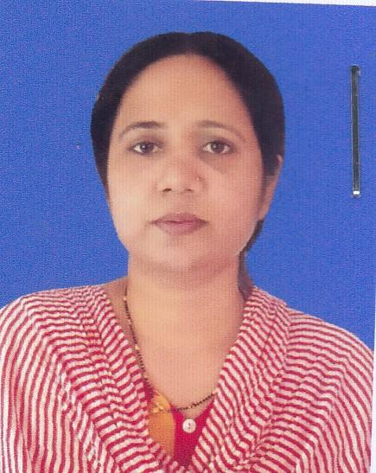 | DR. MARY BANIK  F/Name: Nepal Chandra Kangsha Banik  M/Name: Jharna Banik  BM & DC Reg. No: A 55565  NID: 9196211233976  Cell: 01735036520  Address: Vill: Jhawdanga, Post: Jhawdanga, patkelghata, Thana+Dist: Satkhira.  Blood Group: O+
137 | Voter No  LM-5900137  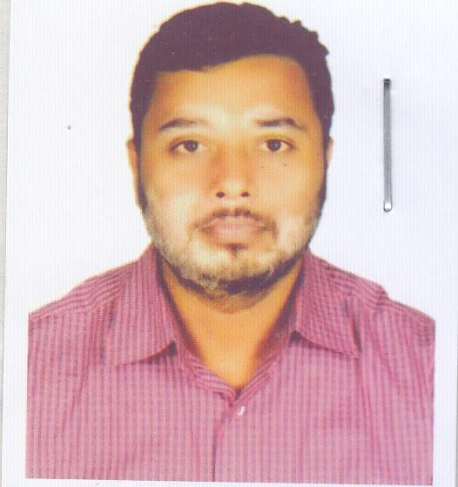 | DR. SUMAN KUMAR DAS  F/Name: Ram Pada Das  M/Name: Champa Rani Das  BM & DC Reg. No: A 46740  NID: 19821322214162443  Cell: 01914148039  Address: Vill+ Post: Bankal, Thana: Satkhira Sadar, Satkhira  Blood Group: A+
138 | Voter No  LM-5900138  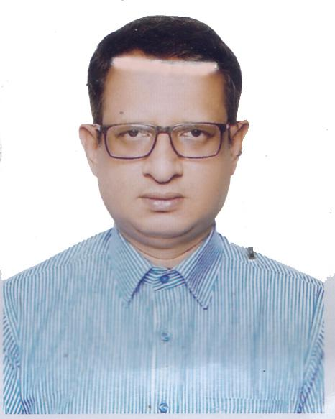 | DR. MD. SAIF ULLAH  F/Name: Late: Al-haj Md. Ibrahim  M/Name: Late: Mrs. Sharifa Khatun  BM & DC Reg. No: 32174  NID: 19733313023777449  Cell: 01720014780  Address: Assistant Professor (Arses), Satkhira Medical College, Satkhira,  Blood Group: O+
139 | Voter No  LM-5900139 | DR. MOUSHUMI RANI SARDER  F/Name: Gobinda Lal Sarder  M/Name: Asima Rani Sarder  BM & DC Reg. No: 65219  NID:  Cell: 01725781874  Address: 4th Floor, Holding No-256/00. Word No-9, Polashpole, Satkhira.  Blood Group: O+
140 | Voter No  LM-5900140 | DR. MANOSH KUMAR MONDAL  F/Name: Dulal Chandra Mondal  M/Name: Anima Bala Mondal  BM & DC Reg. No: 46259  NID:  Cell: 01716840447  Address: 4th Floor, Holding No-256/00 Ward No-9. Polashpole, Satkhira.  Blood Group: O-
141 | Voter No  LM-5900141 | DR. TAMANNA NUSRAT KHAN  F/Name: Md. Emdad Khan  M/Name: Noorjahan Khan  BM & DC Reg. No: 82601  NID: 19932613825000538  Cell: 01726101249  Address: Kamalnagar, Sadar, Satkhira  Blood Group: O+
142 | Voter No  LM-5900142  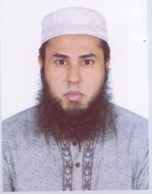 | DR. MD. FARHAD HOSSAIN  F/Name: Md. Subid Ali Molya  M/Name: Firoza Begum  BM & DC Reg. No: 69449  NID: 8710486599043  Cell: 01717495729  Address: Uttar Katia, Polashpole, Satkhira.  Blood Group: B+
143 | Voter No  LM-5900143 | DR. S.M.A. MUKTADIR TAMIM  F/Name: S.m.a. Latif  M/Name: Nurjahan Begum  BM & DC Reg. No: 72998  NID: 19902694266000100  Cell: 01722100951  Address: 63/4, Nurmohol Boyra Market Cross Road, Boyra, Khulna.  Blood Group: B+
144 | Voter No  LM-5900144  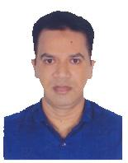 | DR. SHEIKH MAHAMUDUL HASSAN  F/Name: Late: Sheikh Abdul Jalil  M/Name: Hajera Khatun  BM & DC Reg. No: 45689  NID: 9124066599  Cell: 01792073626  Address: Moddho Katia, Sador Satkhira  Blood Group: O+
145 | Voter No  LM-5900145  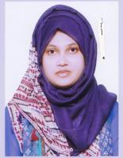 | DR. MANSURA YASMIN  F/Name: Md. Mominul Islam  M/Name: Sabina Yasmin  BM & DC Reg. No: 82684  NID: 19934114789000578  Cell: 01742903378  Address: Ragistrar, Satkhira Medical College (Dept. of Gyeae)  Blood Group: B+
146 | Voter No  LM-5900146 | DR. MD. MUSFIQUR RAHMAN  F/Name: Dr. Md. Habibur Rahman  M/Name: Nasrin Zaman  BM & DC Reg. No: 65365  NID: 5077363553  Cell: 01717417271  Address: Anowora Hemonial Clinic, Polaspole, Satkhira.  Blood Group: B+
147 | Voter No  LM-5900147  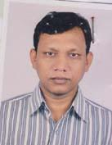 | DR. MD. ZAKIR HOSSAIN  F/Name: Md. Mulluck Chand Sarder  M/Name: Mrs. Rahila Khatun  BM & DC Reg. No: 34692  NID: 9120090130  Cell: 01716929544  Address: Vill- & Post Office: Alipur, P.S- Satkhira Sadar, Satkhira.  Blood Group: B+

